**Assignment 1**

**Q1. Among windows and linux which one provides security and list them down.**

Both Windows and Linux can be secure when configured and managed correctly. The level of security depends on various factors, including how the operating system is used and the security measures implemented. Here are some security aspects of both:

**Windows:**

* **User Account Control (UAC):** UAC prompts users for permission before making system changes, reducing the risk of unauthorized actions.
* **BitLocker:** Encrypts the entire hard drive to protect data at rest.
* **Windows Defender:** Built-in antivirus and antimalware software.
* **Patch Management:** Regular updates and security patches provided by Microsoft.
* **Active Directory:** Offers centralized user management and access control.

|  |  |
| --- | --- |

**Linux:**

* **User Privileges:** Linux follows the principle of least privilege, limiting user rights.

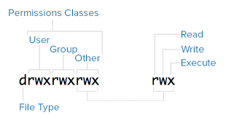

* **Open Source:** Transparency allows for community scrutiny and rapid security fixes.
* **Permissions:** Granular file and directory permissions enhance control.
* **Security-Enhanced Linux (SELinux):** A security feature for access control policies.
* **Firewalls and IPTables:** Robust firewall capabilities.
* **Package Managers:** Simplify software updates and security patching.

It's essential to note that the security of both operating systems heavily depends on the user or administrator's actions and configurations.

**Q2. Explain the critical components of cybersecurity governance.**

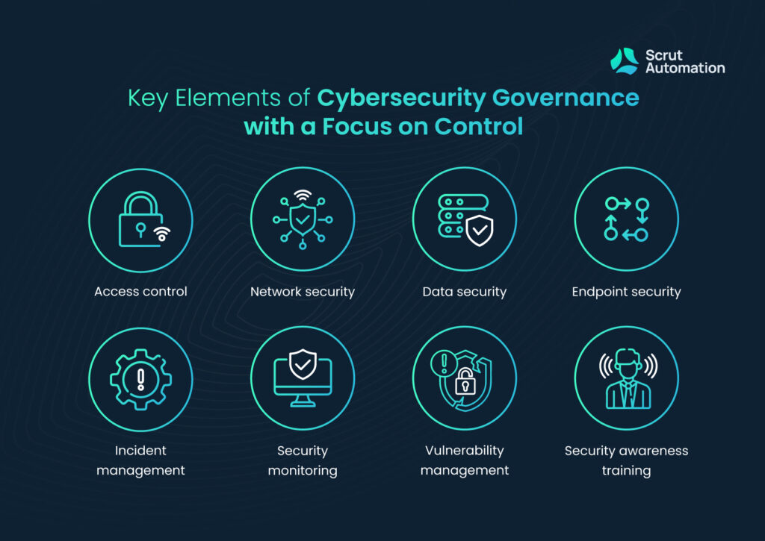

Cybersecurity governance involves establishing policies, procedures, and practices to manage and protect an organization's information assets. Critical components include:

* **Cybersecurity Policies and Procedures:** Define the rules and guidelines for protecting data and systems, including acceptable use policies, incident response plans, and risk management procedures.
* **Risk Management:** Identify, assess, and prioritize cybersecurity risks. Implement risk mitigation strategies and regularly review risk assessments.
* **Compliance:** Ensure compliance with relevant laws, regulations, and industry standards, such as GDPR, HIPAA, or ISO 27001.
* **Security Awareness and Training:** Educate employees and stakeholders about cybersecurity best practices and threats.
* **Incident Response and Management:** Develop a plan for responding to and recovering from security incidents. Define roles and responsibilities.
* **Access Control:** Implement user authentication, authorization, and access control mechanisms to limit unauthorized access.
* **Security Monitoring and Threat Intelligence:** Continuously monitor networks and systems for suspicious activities. Stay updated on emerging threats through threat intelligence.
* **Security Testing and Assessment:** Conduct regular vulnerability assessments, penetration testing, and security audits.
* **Security Architecture:** Design and maintain a secure network and system architecture, including firewalls, intrusion detection systems, and encryption.
* **Third-Party Risk Management:** Assess and manage the security risks associated with third-party vendors and partners.
* **Security Metrics and Reporting:** Measure and report on cybersecurity performance and compliance to stakeholders and senior management.
* **Cybersecurity Culture:** Foster a culture of security throughout the organization, promoting vigilance and responsibility among all employees.

**Q3. Explain the role of the computer emergency response team, the emergency response team for data security mechanisms.**

* **Computer Emergency Response Team (CERT):** CERTs are responsible for responding to and mitigating cybersecurity incidents within an organization. Their roles include:
* **Incident Response:** Rapidly assess and respond to security incidents, minimizing damage.
* **Threat Intelligence:** Collect and analyze information on emerging threats and vulnerabilities.
* **Security Awareness:** Educate employees about security best practices.
* **Vulnerability Management:** Identify and address software vulnerabilities.
* **Security Monitoring:** Continuously monitor networks for unusual activities.

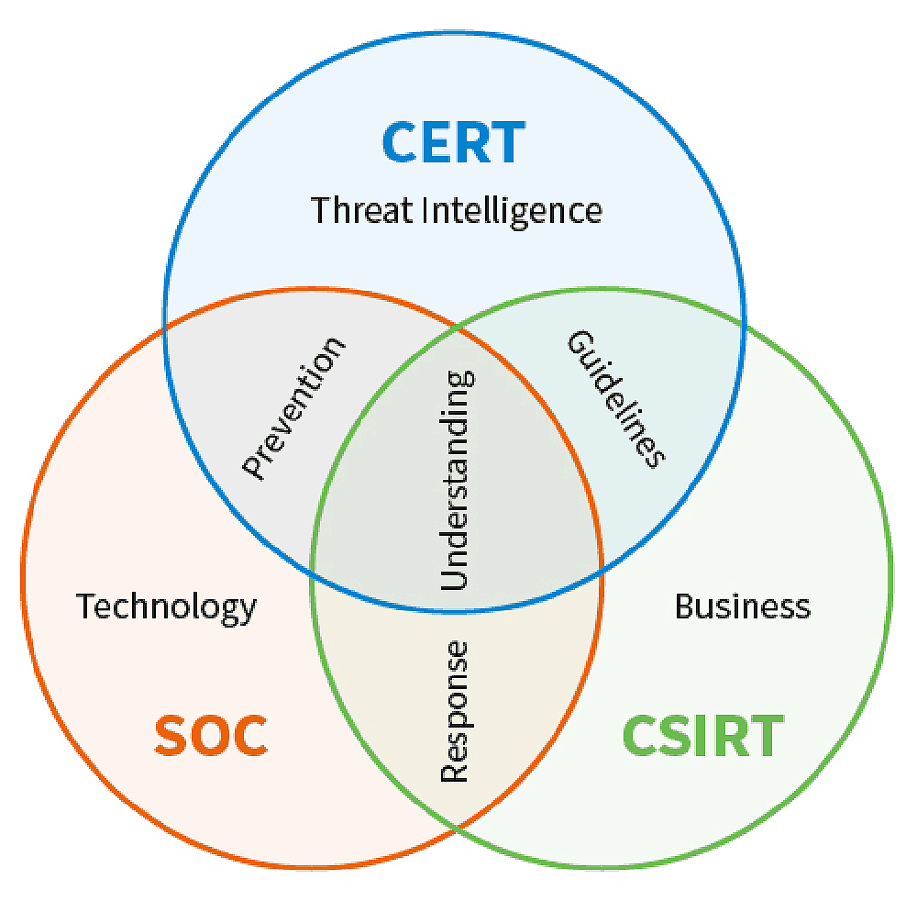

* **Emergency Response Team for Data Security Mechanisms:** This team focuses specifically on safeguarding sensitive data within an organization. Their responsibilities include:
  + **Data Classification:** Categorize data based on sensitivity and importance.
  + **Encryption:** Implement encryption mechanisms to protect data at rest and in transit.
  + **Access Controls:** Enforce strict access controls and permissions to limit data access.
  + **Data Loss Prevention (DLP):** Deploy DLP solutions to prevent unauthorized data leakage.
  + **Data Backup and Recovery:** Ensure data is regularly backed up and can be recovered in case of loss or breach.
  + **Data Retention Policies:** Define and enforce policies for data retention and disposal.

These teams work collaboratively to secure an organization's digital assets and respond effectively to security incidents.

**Q4. What approach can you take to defend the phishing attempts.**

Defending against phishing attempts requires a multi-faceted approach:

* **User Training and Awareness:** Educate employees about the dangers of phishing and how to recognize suspicious emails, links, and attachments.
* **Email Filtering:** Implement robust email filtering solutions that can detect and quarantine phishing emails.
* **Multi-Factor Authentication (MFA):** Require MFA for accessing sensitive systems and data to prevent unauthorized access even if credentials are stolen.
* **URL Filtering:** Use URL filtering tools to block access to known phishing websites.
* **Regular Updates:** Keep operating systems, software, and antivirus tools up to date with the latest security patches.
* **Phishing Simulations:** Conduct phishing simulations to test and train employees on their ability to identify phishing attempts.
* **Strong Password Policies:** Enforce strong password policies, including regular password changes.
* **Incident Response Plan:** Develop an incident response plan that outlines steps to take in case of a successful phishing attack.
* **Email Authentication Protocols:** Implement email authentication protocols like DMARC, DKIM, and SPF to verify email sender authenticity.
* **Security Software:** Use endpoint security software to detect and prevent phishing attempts at the user's device.

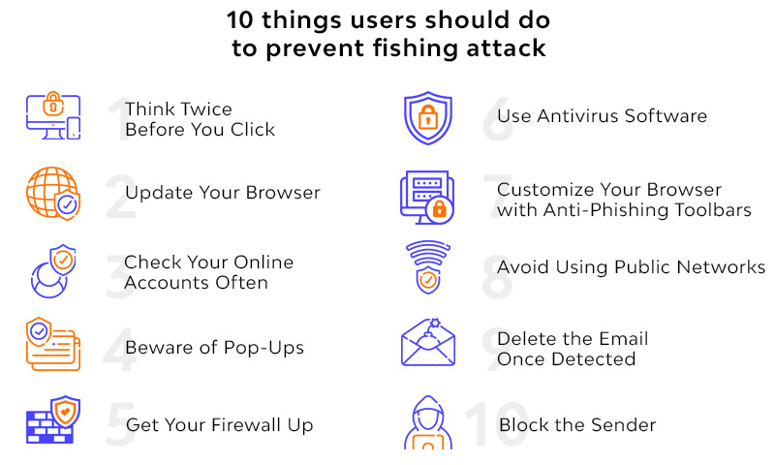

**Q5. Mention the list of challenges for a successful deployment & monitoring the web intrusion detection.**

Deploying and monitoring web intrusion detection systems can be challenging due to:

* **Complexity:** Configuring and maintaining intrusion detection systems can be complex, requiring expertise and resources.
* **False Positives**: IDS systems may generate false alarms, leading to wasted time investigating non-existent threats.
* **Tuning:** Fine-tuning the IDS to reduce false positives while not missing real threats is a delicate balance.
* **Traffic Volume:** High volumes of network traffic can overwhelm IDS systems, impacting their effectiveness.
* **Encryption:** Encrypted traffic can evade traditional IDS, making it challenging to detect threats within encrypted payloads.
* **Zero-Day Attacks:** IDS may not detect new, unknown threats until signatures or detection rules are updated.
* **Alert Fatigue:** Frequent alerts can lead to alert fatigue, causing analysts to overlook genuine threats.
* **Resource Constraints:** Smaller organizations may lack the resources to deploy and maintain sophisticated IDS solutions.
* **Integration**: Integrating IDS with other security tools and workflows can be challenging.
* **Evolving Threats:** Attack techniques are constantly evolving, requiring regular updates and adaptations to detection rules.